Periphery Handling PCB

Rappai Soma

ONQZ95

Table of Content

Table of Content……………………….1

Component ………………………………2

Budget………………………………………3

Design and Make of the board….4

Schematics……………………………….6

Board……………………………………….8

PIC……………………………………………9

Component List

PIC:

* 1 * PIC 18F45K22

Resistors:

* 2 * RES 10K 0.25W 🡪 10kOhm
* 2 * [0207 0.6 W Yageo MF0207FTE52-10R](http://www.conrad.hu/conrad.php?name=Products&pid=1417574) 🡪 10 Ohm

ICs:

* 1 * LD33V3
* 1 * L7805CV
* 1 * SN75176

Capacitors:

* 4 * 100n Ceramic
* 1 * 100u Electrolytic
* 1 * 10u Electrolytic

Button:

* 1 * Würth Elektronik 434121025816

Diodes:

* 2 * 1N4148DO35-7

GPS:

* 1 * microe.com GPS click
* 1 * microe.com GPS antenna

MicorBus sockets:

* 4 * 8-Casing

Budget

|  |  |  |
| --- | --- | --- |
| **Name** | Price in Shop/piece | My price(HUF) |
| PIC 18F45K22 | 2000HUF | 2000 |
| RES 10K 0.25W | 20 HUF | Gift |
| [0207 0.6 W Yageo MF0207FTE52-10R](http://www.conrad.hu/conrad.php?name=Products&pid=1417574) | 35 HUF | Gift |
| LD33V3 | 120HUF | 1200 |
| L7805CV | 150HUF | 1500 |
| SN75176 | 400 | 400 |
| 100n Ceramic | 20HUF | Gift |
| 100u Electrolytic | 600HUF | 600 |
| 10u Electrolytic | 500HUF | 500 |
| Würth Elektronik 434121025816 | 250HUF | Gift |
| 1N4148DO35-7 | 25HUF | Gift |
| microe.com GPS click | $49.00 = 13.000HUF | 13.000 |
| microe.com GPS antenna | $9.90 = 2700HUF | 2700 |
| Casing | ---------------- | Gift |
| Shipping | ------------- | 10000 |

The actual price I paid is ***31900HUF.***

Design and Make of the Board

For Designing the PCB I used the Eagle program. At first the most difficult task was to decide what types of components I want to use. It was a big help for me that the company I work also make PCBs and that my Uncle is an Electrical Engineer. Both my Uncle and the company could help me with the design and also both of them offered that, they’ll give me components if I need them. After this I had an easier time, because their help “limited” me in some of the components. After I finished the design of the board I had to make it. For me it was the first time ever to make a board all on my own so I was a little scared how it will work. As it turned out I was right to worry because it was really hard and it took me some time to make a usable board. I tried 2 times with the full board and countless time with parts of the board so I can learn.

To manufacture the board I used the following method:

1. I prepared the Copper Clad Board

To Prepare The Copper Clad Board :  
  
1. Apply Liquid Soap Or Dishwasher Liquid On The Copper Clad Board  
2. Rub Steel Wool On It Till It Gets Shiny  
3. Rub It With Scotch-Brite  
4. Soak It With Water  
5. Clean It With A Cloth

1. Toner transfer:

For The Toner Transfer:-  
  
1. Heat The iron to its Maximum Setting.  
2. Cut The Design And Place It Upside-Down On The Board And Make Sure That It Is Completely on the Board.  
3. Slowly Move And Press the Iron On The Board with Pressure For 20-25 Minutes.

1. Washing:

After Heating, Wash The Board With Water Till the Paper Completely Gets Removed, Now Only Black Lines Are Left on the Board **DO NOT REMOVE THOSE LINES**.

1. Etching:

**For The Etching:-**  
  
**1.** Boil Approx. 500 ml Of Water In A Utensil For 15-20 Minutes.   
**2.** Pour Ferric Chloride In The Small Container.  
**3.**  Pour The Boiling Water In Ferric Chloride. (The Hotter The Water is, The Less Time The Etching Method Will Take)   
**4.**Also Pour the Boiling Water In The Big Container

**5.**  Put The Small Container In The Big Container, After Doing That Put The Board In The Small Container  
**6.**Keep Checking That The Copper Is Removed Or Not.  
Hold The Board With Tweezers

**7.**If The Copper Is Completely Removed, Then, The Etching Is Done.

1. Washing:

Now Hold The Board With Spoon Or Tweezers And Wash It With Water And Make Sure That The Chemical Is Completely Removed.

1. Remove the toner:

Remove The Toner With A Steel Wool

1. Drill:

Drill The PCB With A 1mm Drill Bit

1. Soldering

Solder every component

Schematics

**Schematic of the Board**

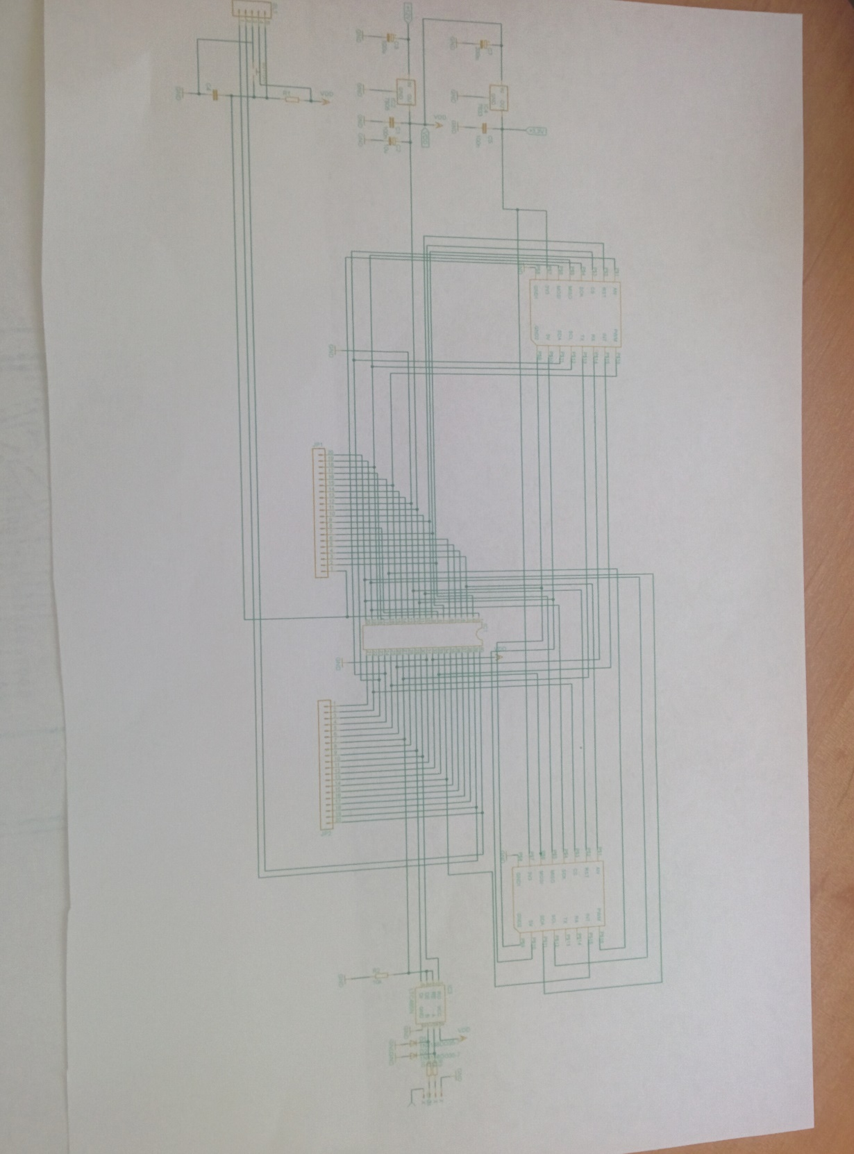

**Schematic of the GPS**

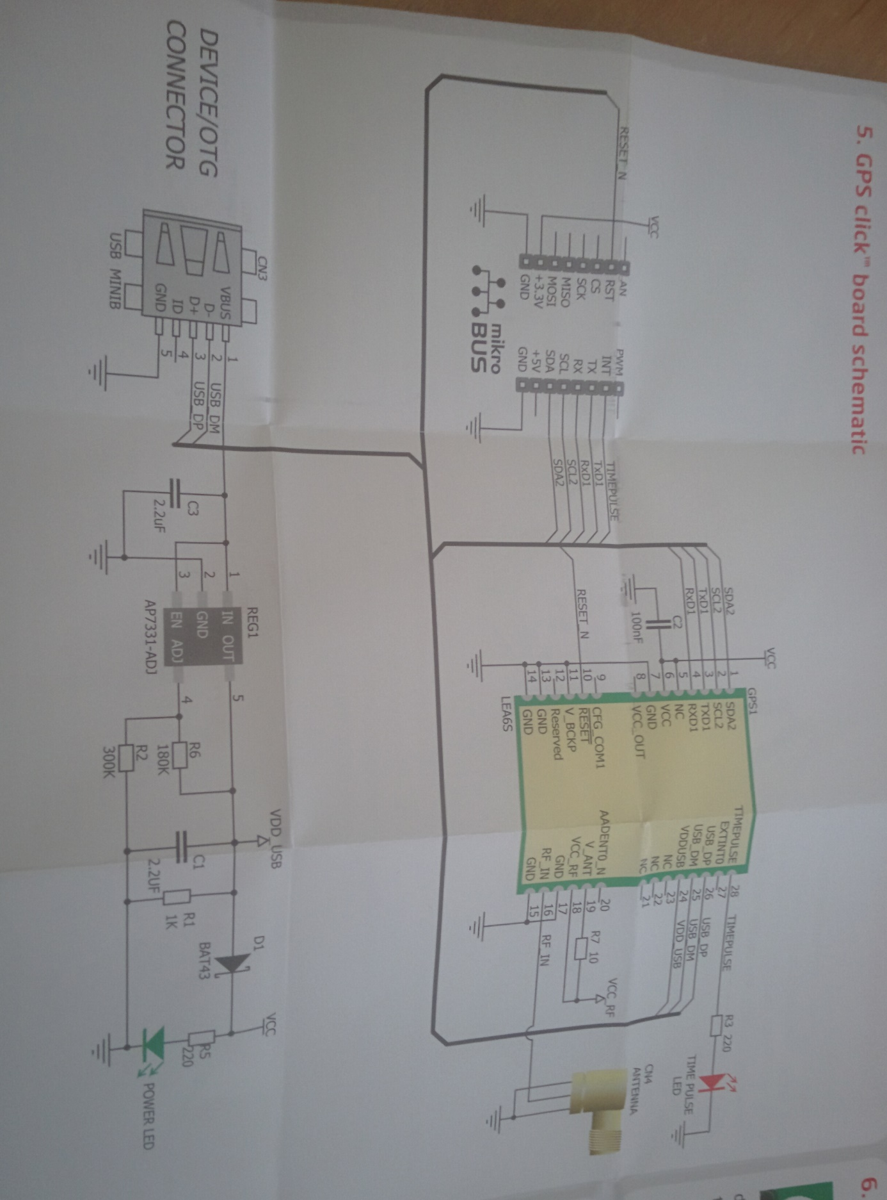

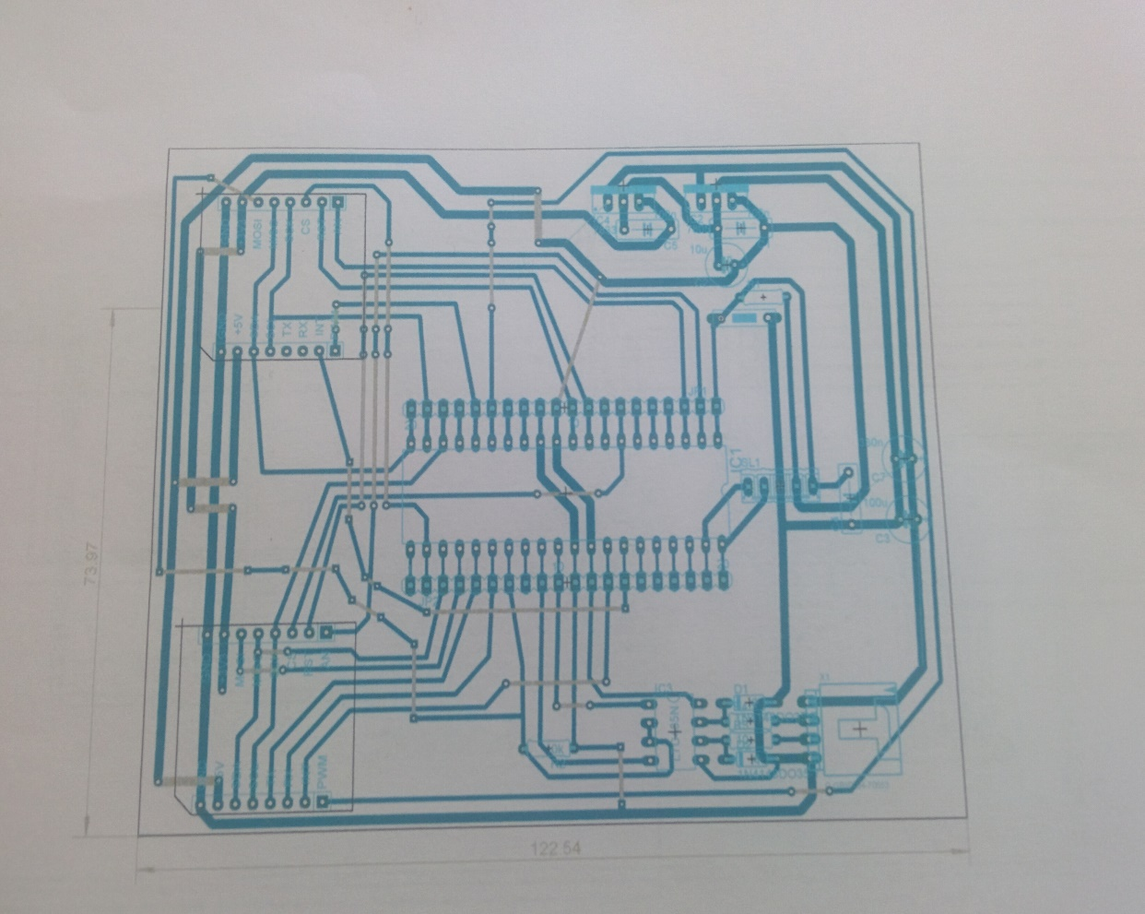Board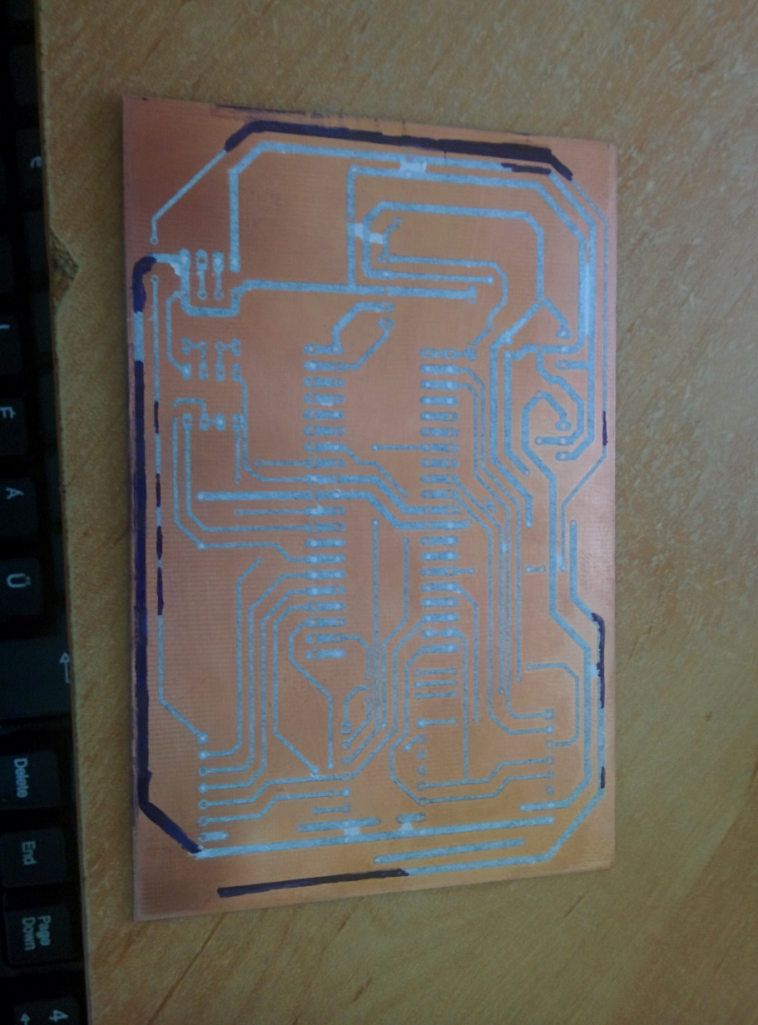

PIC

For this Project I used a PIC18F45K22 module. It is a 40 leg PIC.

A few information:

|  |  |
| --- | --- |
| Program Memory Type | Flash |
| Program Memory (KB) | 32 |
| CPU Speed (MIPS) | 16 |
| RAM Bytes | 1,536 |
| Data EEPROM (bytes) | 256 |
| Digital Communication Peripherals | 2-UART, 2-A/E/USART, 2-SPI, 2-I2C2-MSSP(SPI/I2C) |
| Capture/Compare/PWM Peripherals | 2 CCP, 3 ECCP |
| Timers | 3 x 8-bit, 4 x 16-bit |
| ADC | 28 ch, 10-bit |
| Comparators | 2 |
| Temperature Range (C) | -40 to 125 |
| Operating Voltage Range (V) | 1.8 to 5.5 |
| Pin Count | 40 |
| XLP | Yes |
| Cap Touch Channels | 28 |

I chose this PIC because, I thought if I ever going to upgrade my Project with a few more peripheries I don’t have to reprogram it completely. Plus it have a few great features such as:

* High Performance RISC CPU
* Extreme Low-Power Management
* Special Microcontroller Features:
  + - Full 5.5V operation (PIC18F2XK22/4XK22)
    - Low voltage option available for 1.8V-3.6V operation (PIC18LF2XK22/4XK22)
    - Self-reprogrammable under software control
    - Power-on Reset (POR), Power-up Timer (PWRT) and Oscillator Start-up Timer (OST)
    - Programmable Brown-out Reset (BOR)
    - Extended Watchdog Timer (WDT) with on-chip oscillator and software enable
    - Programmable code protection
    - In-Circuit Serial Programming™ (ICSP™) via two pins
    - In-Circuit Debug via two pins

And more.